**Radhika C**

**LAB-1 RMCA-B**

**ROLL NO:13**

**EXPIRIMENT: 1**

* CREATE TABLE CUSTOMER (CNAME VARCHAR(15) PRIMARY KEY ,CITY VARCHAR(20) NOT NULL );
* CREATE TABLE BRANCH (BNAME VARCHAR(20) PRIMARY KEY,CITY VARCHAR(30) CHECK (CITY IN ('NAGPUR','DELHI','BANGALORE','BOMBAY')) NOT NULL);
* CREATE TABLE BORROW (LOANNO VARCHAR(8) PRIMARY KEY CHECK (LOANNO LIKE 'L%') ,CNAME VARCHAR(15),BNAME VARCHAR(20) ,AMOUNT FLOAT(8,2) NOT NULL CHECK (AMOUNT>0) , FOREIGN KEY (CNAME) REFERENCES CUSTOMER(CNAME), FOREIGN KEY (BNAME) REFERENCES BRANCH(BNAME));
* CREATE TABLE DEPOSIT (ACTNO VARCHAR(5) CHECK (ACTNO LIKE 'D%') PRIMARY KEY,CNAME VARCHAR(15),BNAME VARCHAR(20) ,AMOUNT FLOAT(8,2) CHECK (AMOUNT>0) NOT NULL, FOREIGN KEY (CNAME) REFERENCES CUSTOMER(CNAME), FOREIGN KEY (BNAME) REFERENCES BRANCH(BNAME));
* INSERT INTO CUSTOMER VALUES('ANIL','CALCUTTA');
* INSERT INTO CUSTOMER VALUES('SUNIL','DELHI');
* INSERT INTO CUSTOMER VALUES('MEHUL','BARODA');
* INSERT INTO CUSTOMER VALUES('MANDAR','PATNA');
* INSERT INTO CUSTOMER VALUES('MADHURI','NAGPUR');
* INSERT INTO CUSTOMER VALUES('PRAMOD', 'NAGPUR');
* INSERT INTO CUSTOMER VALUES('SANDIP','SURAT');
* INSERT INTO CUSTOMER VALUES('SHIVANI','BOMBAY');
* INSERT INTO CUSTOMER VALUES('KRANTI','BOMBAY');
* INSERT INTO CUSTOMER VALUES('NAREN','BOMBAY');
* INSERT INTO DEPOSIT VALUES ('D100','ANIL','VRCE',1000.00,'1995-03-01');
* INSERT INTO DEPOSIT VALUES ('D101','SUNIL','ANJNI',500.00,'1996-01-04');
* INSERT INTO DEPOSIT VALUES ('D102','MEHUL','KAROLBAGH',3500.00,'1995-11-17');
* INSERT INTO DEPOSIT VALUES ('D104',' MADHURI','CHANDNI',1200.00,'1995-12-17');
* INSERT INTO DEPOSIT VALUES ('D105','PRAMOD','MG ROAD',3000.00,'1996-03-27');
* INSERT INTO DEPOSIT VALUES ('D106','SANDIP','ANDHERI',2000.00,'1996-03-31');
* INSERT INTO DEPOSIT VALUES ('D107','SHIVANI','VIRAR',1000.00,'1995-09-05');
* INSERT INTO DEPOSIT VALUES ('D108','KRANTI','NEHRU PLACE 50',5000.00,'1995-07-05');
* INSERT INTO DEPOSIT VALUES ('D109',' MINU','WAI',7000.00,'1995-08-01');
* INSERT INTO BRANCH(BNAME,CITY) VALUES ('VRCE','NAGPUR');
* INSERT INTO BRANCH(BNAME,CITY) VALUES ('AJNI','NAGPUR');
* INSERT INTO BRANCH(BNAME,CITY) VALUES ('KAROLBAGH','DELHI');
* INSERT INTO BRANCH(BNAME,CITY) VALUES ('CHANDNI','DELHI');
* INSERT INTO BRANCH(BNAME,CITY) VALUES ('DHARAMPETH','NAGPUR');
* INSERT INTO BRANCH(BNAME,CITY) VALUES ('MG-ROAD','BANGALORE');
* INSERT INTO BRANCH(BNAME,CITY) VALUES ('ANDHERI','BOMBAY');
* INSERT INTO BRANCH(BNAME,CITY) VALUES ('NEHRU-PALACE','DELHI');
* INSERT INTO BRANCH(BNAME,CITY) VALUES ('POWAI','BOMBAY');
* INSERT INTO BORROW VALUES ('L201', 'ANIL','VRCE',' 1000.00');
* INSERT INTO BORROW VALUES ('L206',' MEHUL','AJNI',' 5000.00');
* INSERT INTO BORROW VALUES ('L311','SUNIL',' DHARAMPETH','3000.00');
* INSERT INTO BORROW VALUES ('L321',' MADHURI','ANDHERI','2000.00');
* INSERT INTO BORROW VALUES ('L371',' PRAMOD','VIRAR','8000.00');
* INSERT INTO BORROW VALUES ('L481',' KRANTI','NEHRU PLACE','3000.00');

**EXPERIMENT:2**

1. SELECT * FROM DEPOSIT;

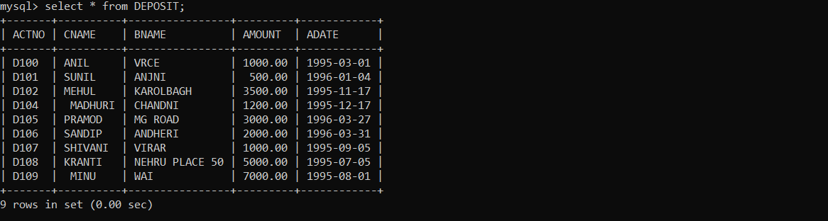

1. SELECT * FROM BORROW;

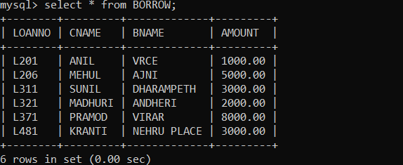

1. SELECT * FROM CUSTOMER;

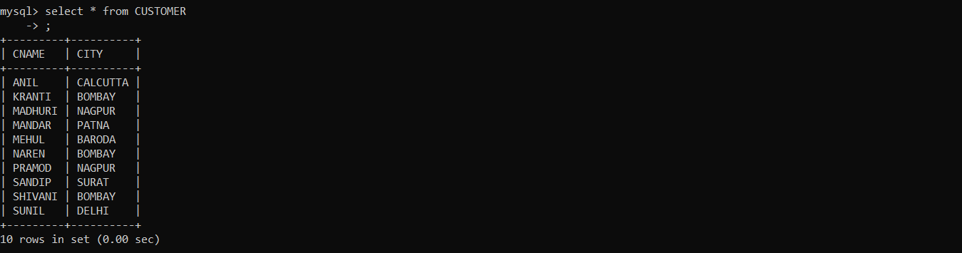

1. SELECT * FROM BRANCH;

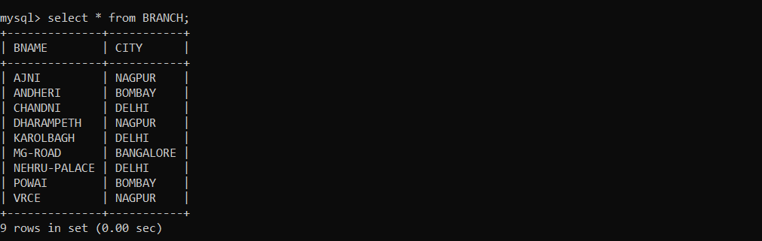

1. SELECT ACTNO,AMOUNT FROM DEPOSIT;

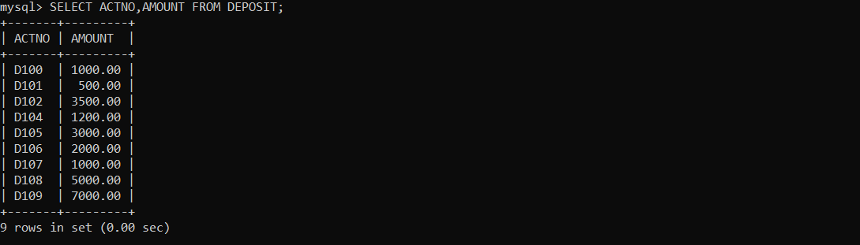

1. SELECT CNAME,ACTNO FROM DEPOSIT;

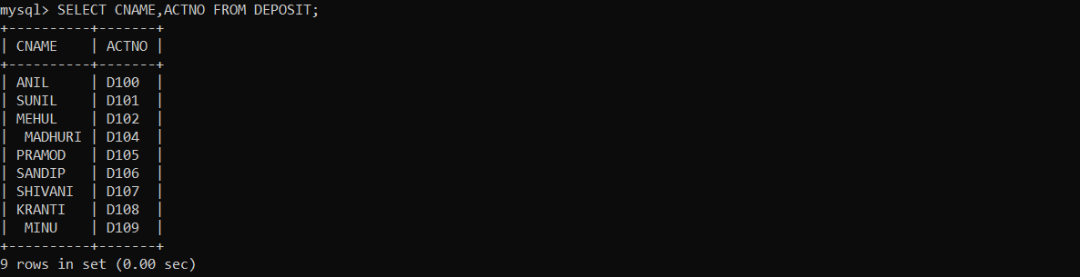

1. SELECT CNAME FROM CUSTOMER;

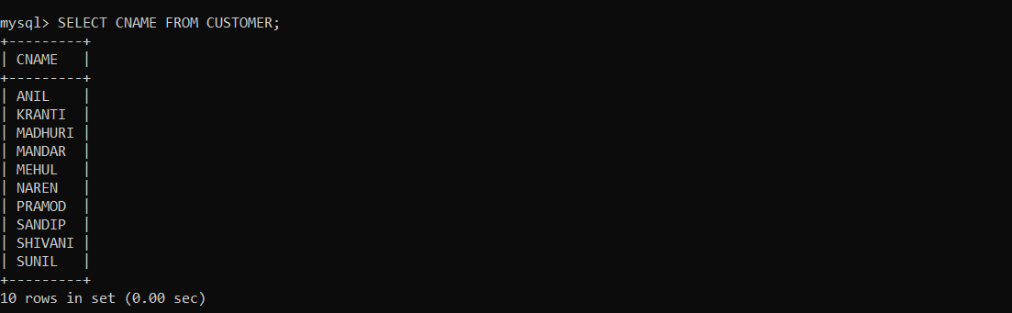

1. SELECT BNAME FROM BRANCH;

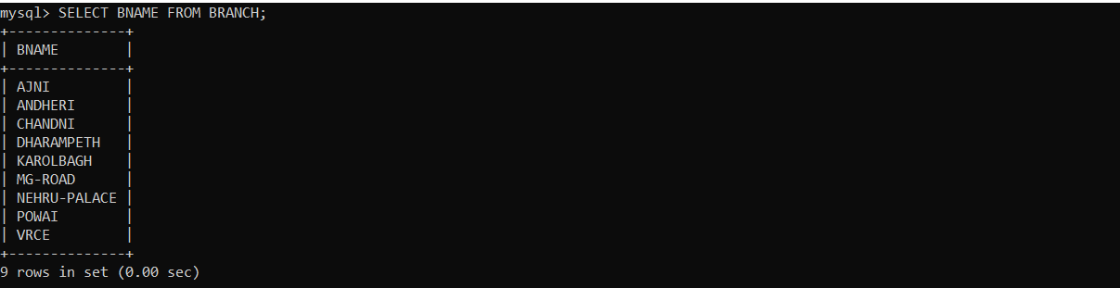

1. SELECT CNAME FROM BORROW;

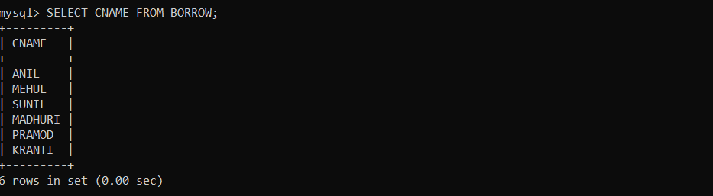

1. SELECT CNAME FROM CUSTOMER WHERE CITY=’NAGPUR’;

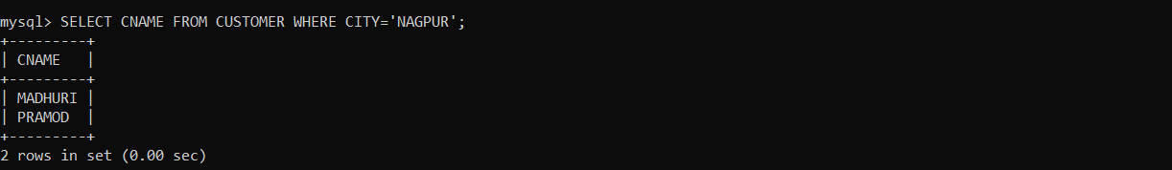

1. SELECT CNAME FROM DEPOSIT WHERE AMOUNT > 4000;

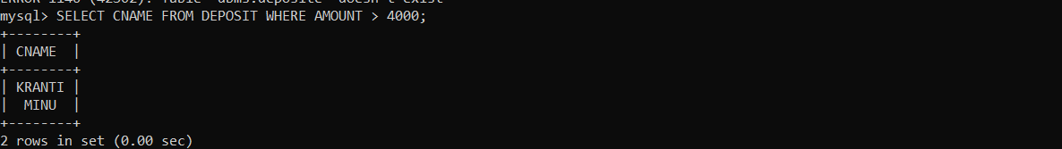

1. SELECT ADATE FROM DEPOSIT WHERE CNAME=’ANIL’;

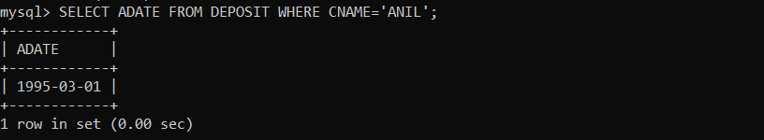

1. SELECT BNAME FROM BRANCH WHERE CITY=’BOMBAY’;

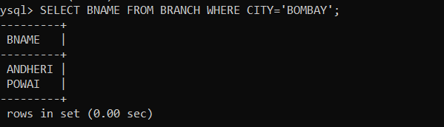

1. SELECT CNAME FROM BORROW WHERE LOANNO=’L201’;

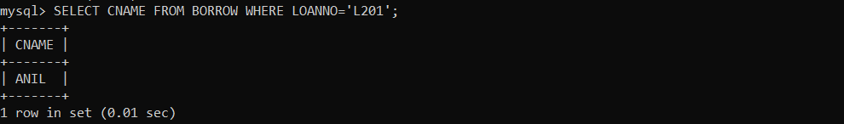

1. SELECT CNAME FROM DEPOSIT WHERE BNAME=’VRCE’;

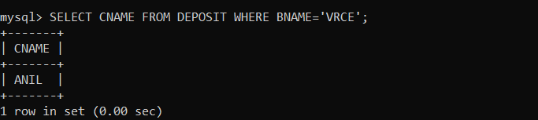

1. SELECT BNAME FROM BRANCH WHERE CITY=’DELHI’;

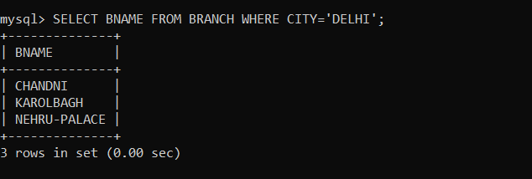

1. SELECT CNAME FROM DEPOSIT WHERE ADATE=’1995-12-17’;

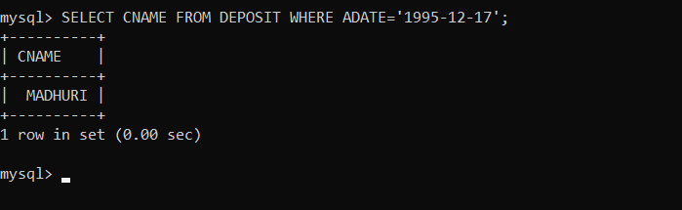

1. SELECT ACTNO,AMOUNT FROM DEPOSIT WHERE ADATE >=’1995-12-01’ AND ADATE <=’1996-05-01’;

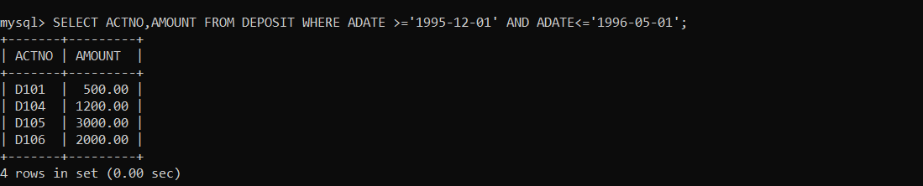

1. SELECT CITY FROM BRANCH WHERE BNAME=’KAROLBAGH’;

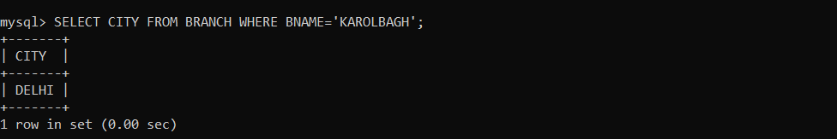

1. SELECT D.ACTNO,D.CNAME,D.BNAME,D.AMOUNT,B.LOANNO,B.AMOUNT FROM DEPOSIT D,BORROW B WHERE B.CNAME=’ANIL’ AND D.CNAME=’ANIL’;

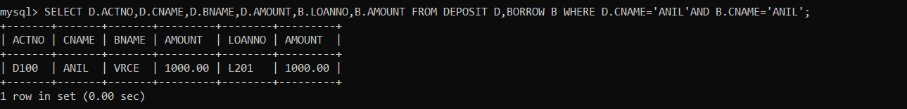

**EXPERIMENT:3**

CREATE TABLE EMP(EMPNO NUMERIC(4),ENAME CHAR(10),HIREDATE DATE,SALARY FLOAT,COMM INTEGER(20),PRIMARY KEY(EMPNO));

* INSERT INTO EMP VALUES(101,"RAMESH","1980-01-17",5000,NULL);
* INSERT INTO EMP VALUES(102,"AJAY","1985-07-05",5000,500);
* INSERT INTO EMP VALUES(103,"RAVI","1981-08-12",1500,NULL);
* INSERT INTO EMP VALUES(104,"NIKESH","1983-03-03",3000,700);
* INSERT INTO EMP VALUES(105,"RAVI","1985-07-05",3000,NULL);

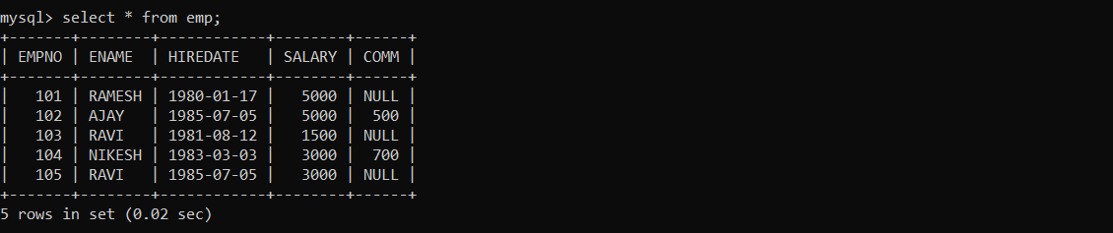

ALTER TABLE EMP ADD SAL INTEGER(7);

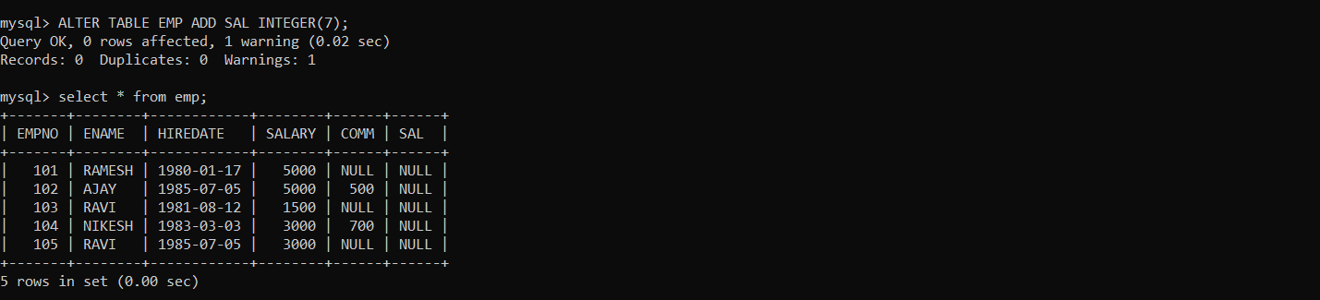

ALTER TABLE EMP DROP SAL;

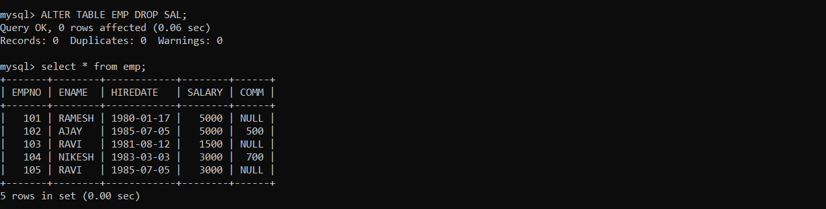

ALTER TABLE EMP MODIFY ENAME VARCHAR(10);

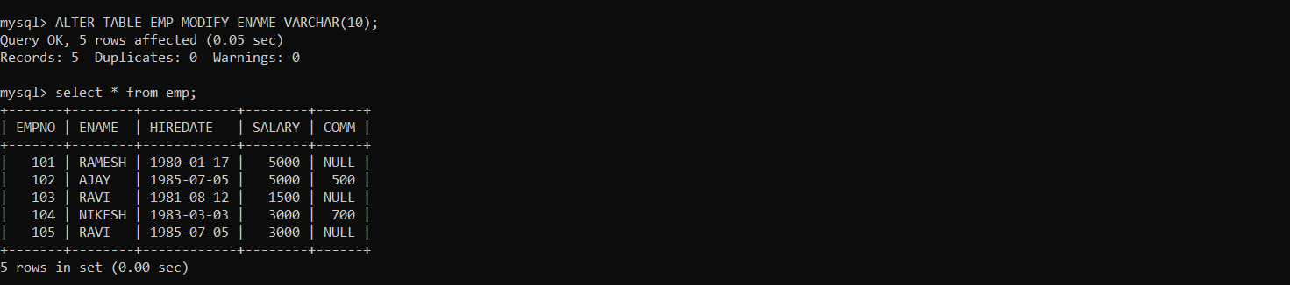

ALTER TABLE EMP RENAME TO EMP1;

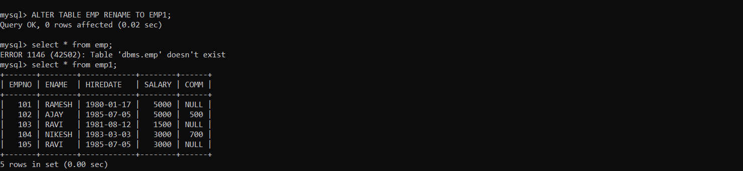

TRUNCATE TABLE EMP1;

